# Cross validation

Cross-Validation is a technique used to assess how well our Machine learning models perform on unseen data

## Why Validate?

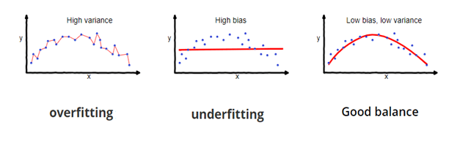

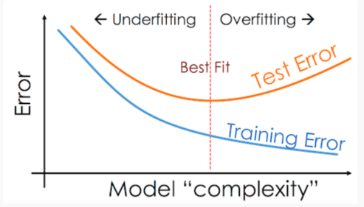

## Splitting the Data:

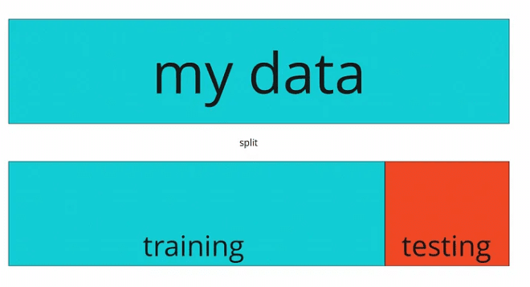

### K Fold



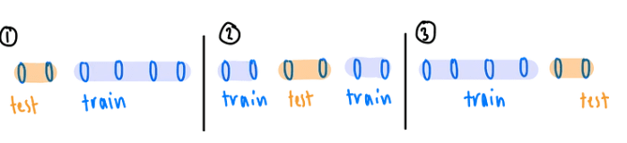

### Stratified

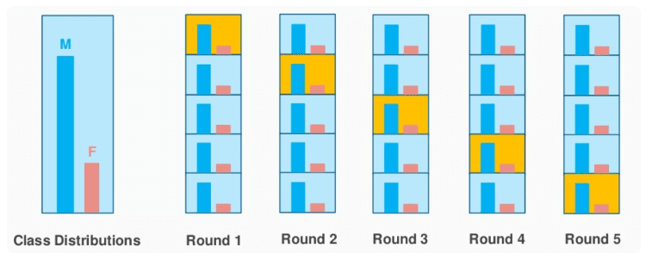

### Leave one out:

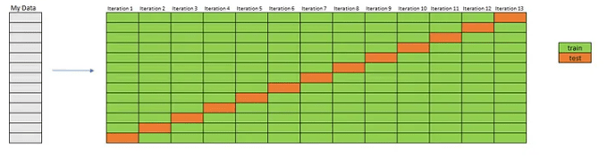

### Monte Carlo - Random Sub Sampling

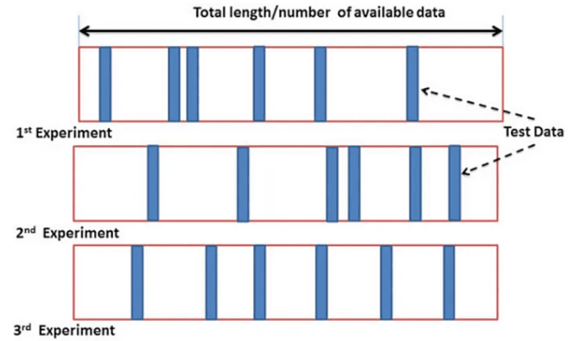

## Hyper-parameter

## Hyper-parameters are parameters that are not directly learnt within estimators. In scikit-learn they are passed as arguments to the constructor of the estimator classes.

